Asmaa Aly
Final Project Proposal
Fall 2020

Introduction
For my final project, I plan to focus on causality research on COVID-19. With the abundance of data and research papers on the topic, I will be working on writing a research paper that provides a comprehensive literature review of previous work doing casual analysis of COVID-19 and government response. The literature review will include papers and data resources that focused on calculating the impact of certain policies on metrics such as death rate and confirmed cases. For each paper included, I will provide a summary of their approach, results, and a detailed critique of the methods under the criteria we study in Pearl’s causality ladder.

Second, I will replicate the Causal impact of masks, policies, behavior on the early covid-19 pandemic in the U.S. by Victor Chernozhukov, Hiroyuki Kasahara, and Paul Schrimpf. I found the paper to capture almost all concepts we covered during the semester, and one of the authors co-wrote the Double Machine Learning. I will replicate their results using the CasualML and EconML packages as an alternative. This paper will be the focus of my final project. I plan to replicate, and if I have enough time, I will try to apply the same model and their approach on a global scope since the original paper is US-centric.

Background Context on the Paper of Interest
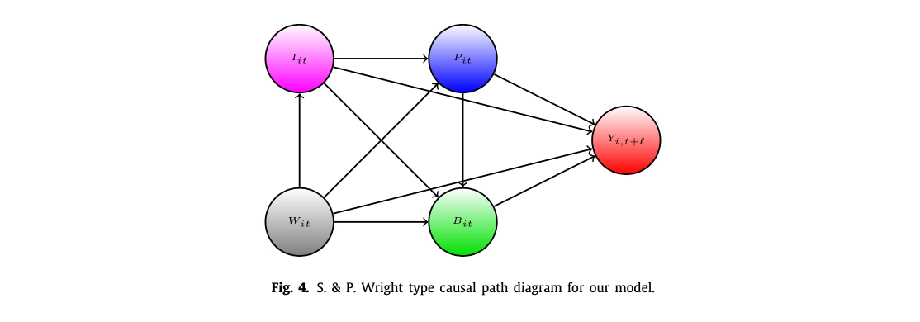
Causal model as detailed in the paper (Chernozhukov et al., 2020).

The goal of the paper is to estimate the causal impact of I, information variables, P, policies adopted, B, human behavior such as going shopping, and Y, the outcomes of interest: growth rates in Covid-19 cases and deaths. The replication code for the paper is available using this link, and it is written in R. The author used double machine learning to estimate direct treatment effects and incorporated counter-factual calculations.

Target Learning Outcomes
#CausalTheory
I plan to use this LO to critique the papers I will include in my literature review. I will also highlight the causal theory in the paper of interest.
#CausalTools
I plan to use this LO by creating DAGS for each causal model I come across in the literature review. Also, I will explain the causal structure and counterfactual calculations provided in the paper of interest.
#CausalApplication
I plan to use this LO throughout my paper since I am replicating one. I will have a detailed description of how I apply the causal theory in the paper and replicate the methods using Python libraries such as EconML and CausalML.

Detailed Outline
Introduction
Literature Review Paper (Subject to Change):
- The Effect of Large-Scale Anti-Contagion Policies on the COVID-19 Pandemic
- Global Assessment of the Relationship between Government Response Measures and COVID-19 Deaths

Replication of paper of interest: Causal impact of masks, policies, behavior on the early covid-19 pandemic in the U.S.
- Introduction to the paper, their approach, and summary of results
- Detailed overview of data collection and data preprocessing for my replication
- Overview of my replication model and key difference using CausalML and EconML to replicate the results.
Results
- Include the results of the original paper
- Include the results of my replication

Discussion
- Compare and contrast the original paper and the replication
- Highlight any key differences in results
- Interpret the results
- Highlight key challenges in replicating the results
Conclusion

References

Chernozhukov, V., Kasahara, H., & Schrimpf, P. (2020). The causal impact of masks, policies, behavior on early covid-19 pandemic in the U.S. Journal of Econometrics. https://doi.org/10.1016/j.jeconom.2020.09.003
Global-Policy-Lab/gpl-covid. (2020). [Jupyter Notebook]. Global Policy Lab. https://github.com/Global-Policy-Lab/gpl-covid (Original work published 2020)
Ubcecon/covid-impact. (n.d.). GitHub. Retrieved November 24, 2020, from https://github.com/ubcecon/covid-impact

